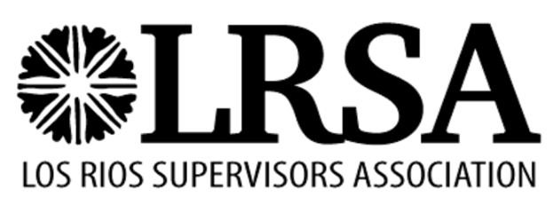

LOS RIOS COMMUNITY COLLEGE DISTRICT

LOS RIOS SUPERVISORS ASSOCIATION (LRSA) MEMBERSHIP AGREEMENT

The Agreement between LRSA and the Los Rios Community College District recognizes LRSA as the exclusive representative for all employees in the bargaining unit. In a special balloting conducted by the Public Employment Relations Board, a majority of the employees voted in favor of requiring a representation fee of all members of the bargaining unit.

TO: Human Resources, Classified Specialist
Los Rios Community College District
1919 Spanos Court
Sacramento CA 95825-3981

- I choose to be an association member in good standing. Therefore, I hereby authorize a payroll deduction from my earnings in the amount of twenty dollars ($20) per month for a total of $240 annually, which shall be remitted to LRSA.

- I recognize that under law LRSA is my exclusive bargaining representative. However, I choose not to be an association member.

Print Employee Name Employee ID Number

Job Title

Work Location

Employee Signature Date

Distribution: Original: Payroll Copy: LRSA President

LRSA Membership Agreement - Revised: 8/15/19

